Grazioso Salvare Dashboard – CS 340

About the Project

This project implements a dashboard for Grazioso Salvare that integrates a MongoDB backend with a Python Dash web application. The dashboard allows users to view and filter animal data from the Austin Animal Center (AAC) database based on rescue type (e.g., water, mountain, disaster, or general tracking rescues).
Functionality
- Connects to AAC MongoDB.
- CRUD operations via AnimalShelter class.
- Dashboard displays animals on a table and on a map.
- Filter buttons: Tracking, Water, Mountain, Disaster rescues.
Screenshots:
Initial View: Displays all animals in the database.
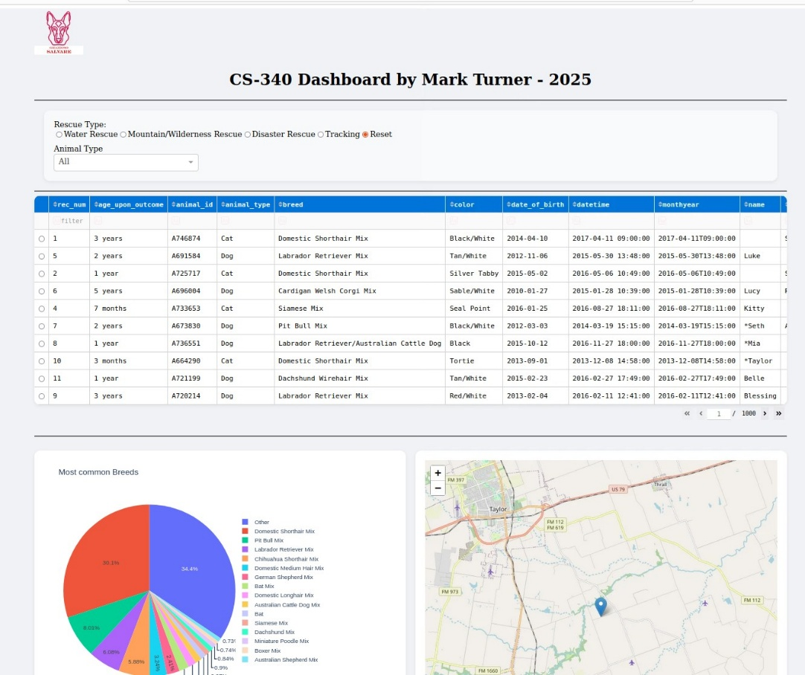
Tracking Filter: Shows animals suited for tracking rescues.
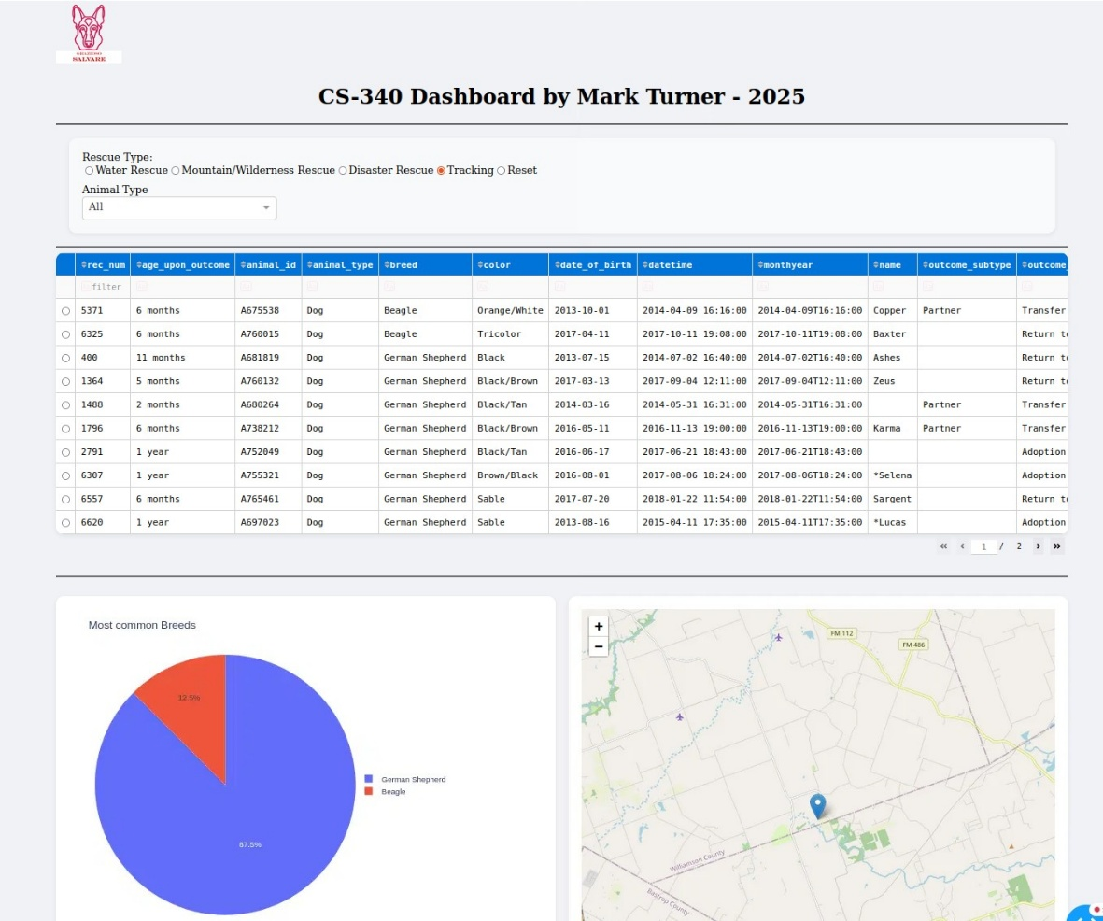

Water Rescue Filter: Displays animals suited for water rescues.
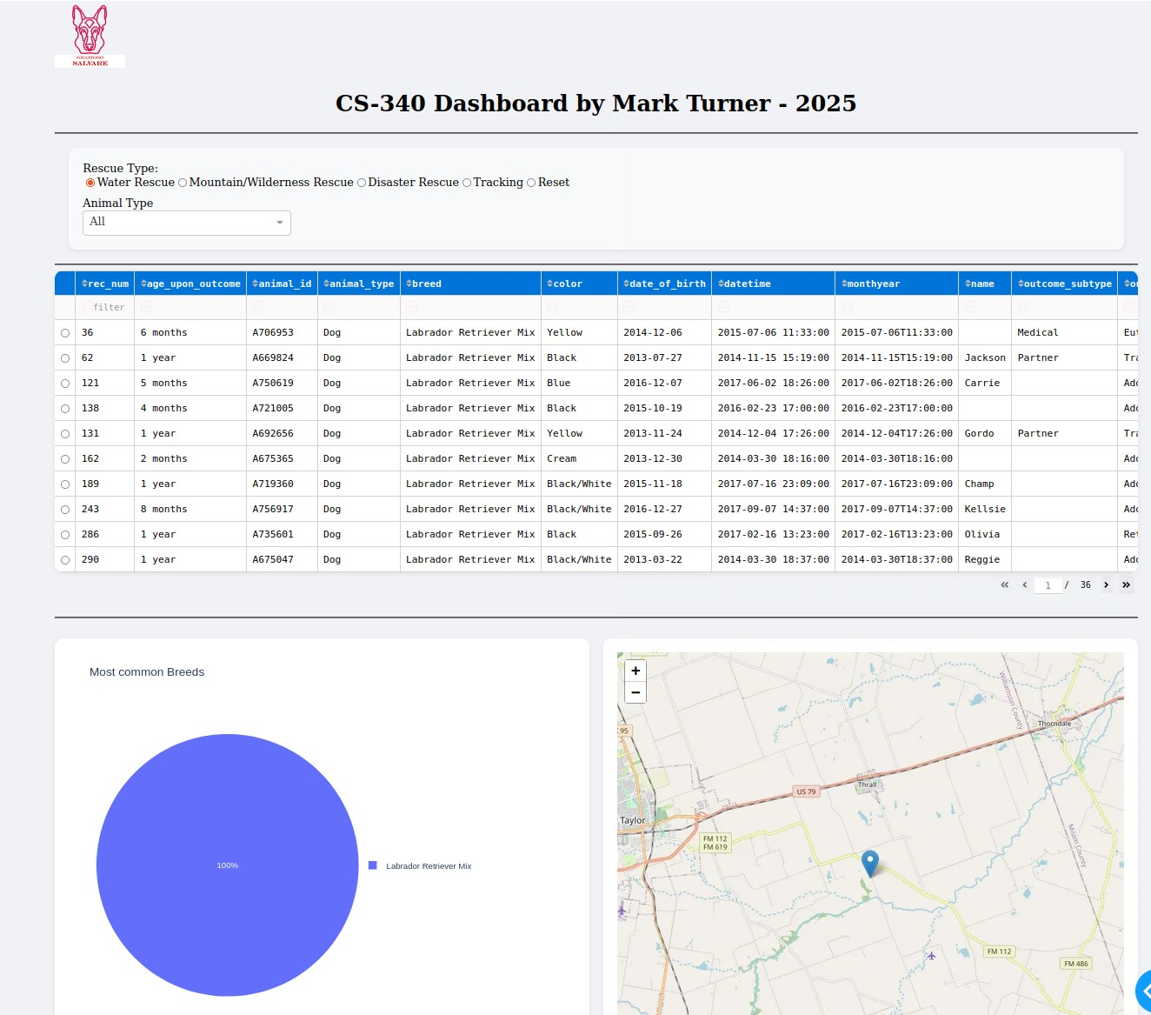

Mountain Rescue Filter: Displays animals suited for mountain rescues.
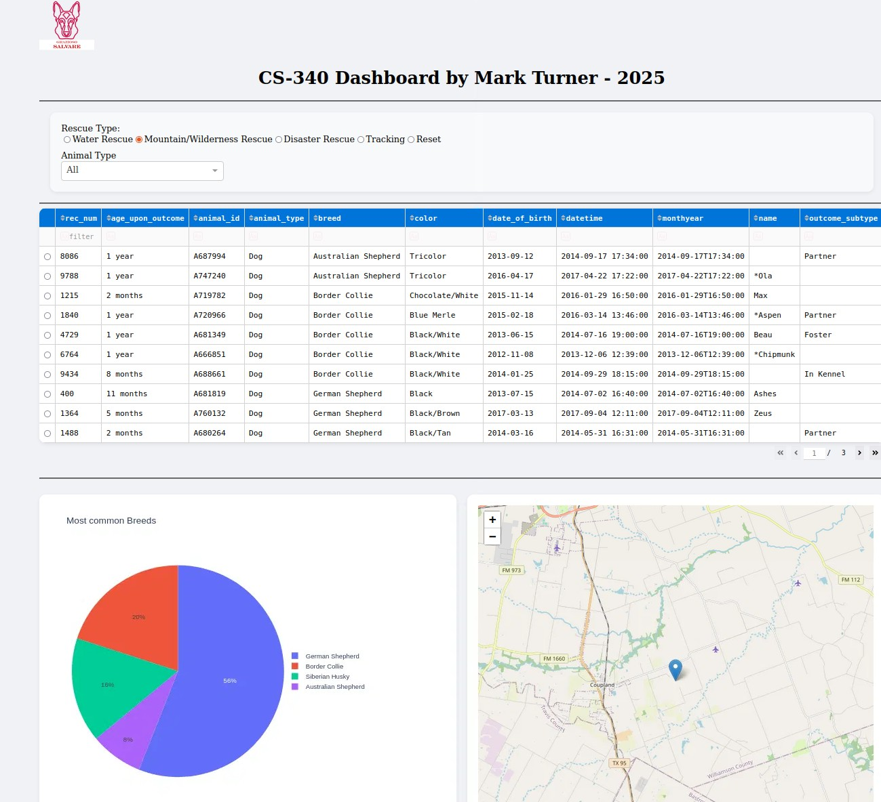

Disaster Rescue Filter: Displays animals suited for disaster rescues.
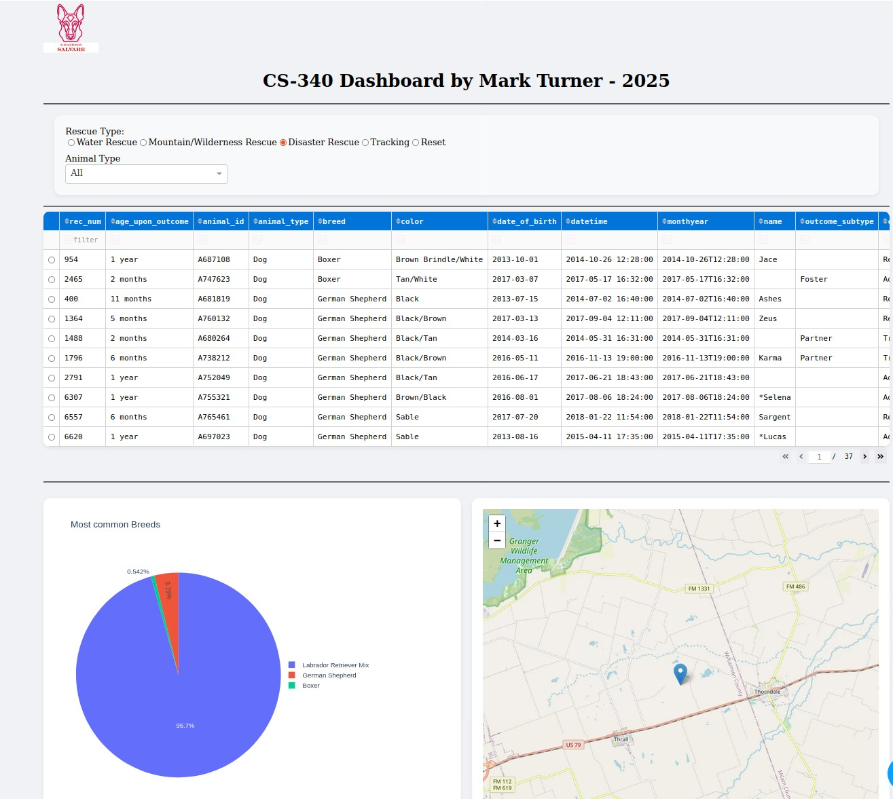

Tools and Rationale
- MongoDB: Used as the model in the MVC pattern because it stores animal records in a flexible, JSON-like format that maps directly to Python dictionaries. Its schema-less design supports varied animal data, and it includes geospatial query capabilities for mapping locations, which are a part of the dashboard.
- pymongo (Python MongoDB Driver): Provides CRUD operations and integrates with Python.
- Dash (Plotly Dash Framework): Serves as the view and controller, enabling the entire dashboard to be built in Python without separate front-end code. Dash uses callbacks to connect user inputs (filter buttons) to MongoDB queries and dynamically updates tables and charts.
- Jupyter Notebook: Used during development and testing to validate CRUD operations.
Steps Taken to Complete the Project
- Setup MongoDB + AAC dataset.
- Built AnimalShelter class for CRUD.
- Tested CRUD in Jupyter.
- Created Dash dashboard (table + map + filters).
- Validated and deployed.
Steps to Reproduce the project
- Clone the repository
- Install Python 3 and pip
- Install pymongo
- Update the connection details in the AnimalShelter class to match your MongoDB instance credentials.
- Start Jupyter Notebook to test OR import the AnimalShelter class into another script to test the connection to the database.

Installation
- Python 3.x
- MongoDB
- pymongo Python library
- Jupyter Notebook (for interactive testing)

Challenges and Solutions
- Authentication Issues: Matching the authentication database name (case-sensitive) with the MongoDB instance caused connection failures.
  - Solution: Verified user credentials and explicitly set the authSource parameter in pymongo.
References
- MongoDB, Inc. (n.d.). MongoDB documentation. MongoDB. https://www.mongodb.com/docs/
- MongoDB, Inc. (n.d.). PyMongo documentation. MongoDB. https://pymongo.readthedocs.io/en/stable/
- Plotly. (n.d.). Dash documentation. Plotly. https://dash.plotly.com/
- City of Austin, Texas. (n.d.). Austin Animal Center outcomes dataset. Data Austin. https://data.austintexas.gov/

